INS270

**Managing Risk to Ensure Business Continuity at Maryland & Virginia Milk Producers Cooperative Association (A)**

01/2013-5921

This case was written by Sarah Goldthwait Shoemaker, Research Associate, and Enver Yücesan, Professor of Operations Management at INSEAD. It is intended to be used as a basis for class discussion rather than to illustrate either effective or ineffective handling of an administrative situation.

To the memory of Professor Paul Kleindorfer.

Additional material about INSEAD case studies (e.g., videos, spreadsheets, links) can be accessed at cases.insead.edu.

Copyright © 2013 INSEAD

COPIES MAY NOT BE MADE WITHOUT PERMISSION. NO PART OF THIS PUBLICATION MAY BE COPIED, STORED, TRANSMITTED, REPRODUCED OR DISTRIBUTED IN ANY FORM OR MEDIUM WHATSOEVER WITHOUT THE PERMISSION OF THE COPYRIGHT OWNER.

# The Wake-Up Call

On a chilly February morning that would make even the heartiest Washington, D.C.-area commuter want to stay in bed, Fred Calvert, the COO of Fluid Milk Operations at Maryland & Virginia Milk Producers Cooperative Association, arrived at the office before sunrise to get a head-start on the busy day ahead.

He began the morning with his usual ritual: scanning industry news from across the country with a cup of milky hot chocolate in hand. He casually clicked through the articles until the words ‘60 percent capacity’ and ‘fire’ caught his eye and caused him to sit up straighter in his chair. The dairy plant fire described in the *Bellingham Herald* article hit too close to home.



**Lynden Darigold Plant Running at 60 Percent Capacity after Fire1**

22 Feb. 2012

LYNDEN, Wash. —The Darigold milk plant that was damaged in a fire over the weekend could take months to get back to full capacity, according to a spokeswoman for the company. The milk plant, located at 8424 Depot Road, is operating at 60 percent of capacity after the fire damaged one of two dryers that turn milk into powder, spokeswoman Michelle Carter said. Carter estimated that it could take three to five months to repair the damage and get back to full capacity at the plant, which usually converts about 4 million pounds of milk into powder every day. The majority of that powder is then exported.

Nearly 30 firefighters from Lynden, North Whatcom Fire and Rescue, and Whatcom County Fire District 7 in Ferndale responded to the plant at about 12:30 a.m. Sunday, after an earlier fire in a dryer had apparently spread to another part of the building.

Firefighters responded to the original dryer fire at about 10:30 p.m. Saturday, and with help from Darigold engineers using special sensors, they believed that the fire was out. But those sensors may have been damaged by the fire and not working properly, and about two hours later Darigold employees heard a blast as the second fire erupted. Flames and smoke billowed from the burning building, and a Darigold employee was trapped on top of a silo at the centre of the building.

The exact cause of the dryer fire remains under investigation, and Carter didn’t yet have hard numbers for how much damage the plant sustained in the blaze. She also couldn’t say how plant workers might be affected.

1. Fraley, Zoe. “Lynden Dairy Plant Running at 60 Percent of Capacity After Fire.” The Bellingham Herald.

22 Feb. 2012. Web 21 June 2012.

[<http://www.belling](http://www.bellinghamherald.com/2012/02/22/2403857/lynden-darigold-plant-)h[amherald.com/2012/02/22/2403857/lynden-darigold-plant-](http://www.bellinghamherald.com/2012/02/22/2403857/lynden-darigold-plant-) running.html#storylink=misearch>.

# Call for Action

After finishing the article, Fred sent it to Jan tenPas, the cooperative’s director of finance and

fluid milk operations, with the subject ‘READ IMMEDIATELY’.

A few minutes later, Fred appeared in Jan’s office with a concerned look that couldn’t be mistaken. As a long-time colleague of Fred, Jan knew exactly what Fred had in mind: ensuring that Maryland & Virginia was doing everything it could to prevent similar disruptions at its own facilities, and ensuring that Maryland & Virginia had an effective business continuity plan in place – one that was ready to be put into action within minutes of a crisis occurring. The time had come to take action.

It did not take long for Fred and Jan to send an e-mail to Jay Bryant, Maryland & Virginia CEO, Don Utz, COO of Manufacturing Operations, Mike John, COO of Milk Marketing and Member Services, and Amber Sheridan, Director of Corporate Communications, summoning them to a day-long workshop and planning meeting dedicated to risk and crisis management.

Two weeks later, the invitees gathered at the Maryland & Virginia headquarters. They strode past the paintings of happy, healthy cows that adorned the office, and took their seats in the conference room. They were prepared to discuss the potential crisis management challenges that the cooperative faced as well as developing an action plan for mitigating and responding to these challenges when – and not if – a crisis hit.

In advance of the meeting, Fred and Jan had asked each colleague: 1) to identify potential sources of risk in their areas of responsibility, 2) to prioritize the risks based on their potential business impact, and 3) to suggest mitigation strategies for each risk. Fred and Jan were interested in getting a handle on Maryland & Virginia’s overall state of crisis preparedness – from risks ranging from “issues” (e.g., harmful claims from activist environmental groups or equipment malfunctions) to potentially devastating “crises” (e.g., a widespread outbreak of Foot-and-Mouth Disease or the outbreak of a lethal foodborne illness).

# Maryland & Virginia Milk Producers Cooperative Association Inc. (Maryland & Virginia)

The 92-year-old Maryland & Virginia Milk Producers Cooperative Association (Maryland & Virginia) is owned and operated by 1,500 dairy families whose farms span the Mid-Atlantic and Southeast regions of the U.S. With farms ranging in size from 100 to 2,000 dairy cows, Maryland & Virginia members produce an average of 3 billion pounds (1.3 billion kilos) of milk each year.

The Cooperative ended 2011 operations with an EBITA of $15.7 million and member equity of $34.8 million. Revenues were up by $143 million in 2011 compared to 2010, for a total annual revenue of nearly $1.4 billion. This increase was due primarily to higher raw milk prices and an increase in member milk production.

Headquartered in Reston, Virginia, Maryland & Virginia is governed by a 16-person board of directors, including three directors from each of the cooperative’s five member districts. One public director is appointed to provide an outside business perspective.

Collectively, the cooperative’s three fluid milk processing plants and two manufacturing (balancing) plants process 52 of the 175 tanker truck loads of raw milk Maryland & Virginia members produce on a daily basis. Due to the cooperative’s limited processing capacity, the 123 loads of raw milk that aren’t processed at Maryland & Virginia facilities are marketed to other processors in the Mid-Atlantic area. The cooperative also owns a farm supply equipment outlet. (Maryland & Virginia’s ecosystem is shown in Figure 1).

Maryland & Virginia’s fluid milk processing plants produce ready-to-drink milk (skim, 1% fat, 2% fat, and whole milk) as well as buttermilk and blended mixes (soft serve ice cream mix and egg nog). These products are sold primarily to retail and institutional customers, including Starbucks, Wal-Mart, the Giant Food supermarket chain, and local school districts.

The manufacturing plants “balance” demand by turning surplus fluid milk that is not needed by the processing plants into products that are typically used as ingredients for sour cream, cream cheese, butter and powdered milk. Customers for these products include consumer packaged goods (CPG) companies such as Nestlé and Unilever as well as third-party brokers.

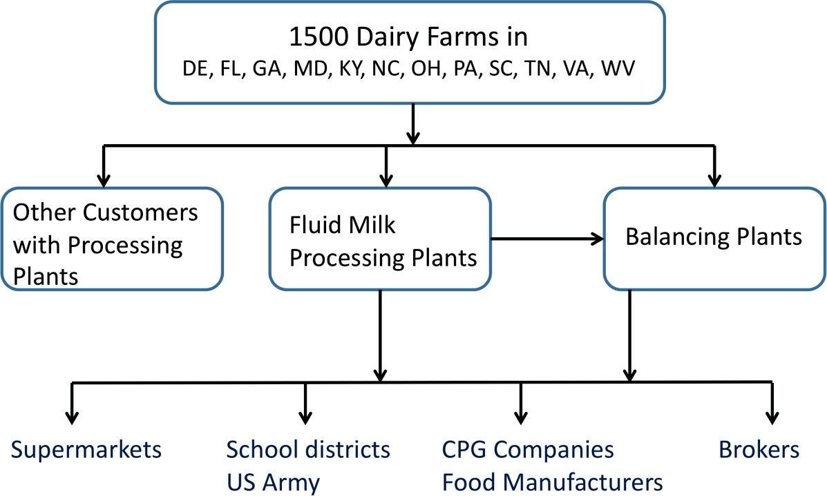

**Figure 1.** Maryland & Virginia’s Ecosystem

## Maryland & Virginia Supply Chain

Milk tanker trucks collect raw milk (unpasteurized, fresh-from-the-cow milk) from all of the 1,500 Maryland & Virginia member farms. As milk is collected at each individual farm, a sample is reserved for individual laboratory analysis. Maryland & Virginia members have direct access to the lab results through a dedicated web site and a telephone hotline, allowing each farmer to remain constantly up-to-date regarding the quality of the milk his or her herd is producing. This quality assurance step measures for bacteria count (preliminary incubation and standard plate counts), somatic cell count (against any possible infection), antibiotics, and

glycaemic index. While Maryland & Virginia pays a premium for high-quality milk, it also imposes a penalty for lack of quality – reserving the right to refuse a load if it does not meet the cooperative’s quality standards.

The raw milk from member farms is commingled in the milk tanker trucks and transported to one of the five Maryland & Virginia plants for processing. Once the truck arrives at the facility, another sample, which tests primarily for the presence of animal drug residues, is taken for analysis before the tanker truck contents are pumped into raw milk storage silos. Any milk that tests positive for antibiotics (above the U.S. government-established tolerance level) is disposed of and does not enter the food supply.

Given the diversity and geographic differences of the cooperative’s farms, the co-mingled raw milk in the silos does not have a uniform consistency. The raw milk is thus processed through a separator where it is separated into skim milk and raw cream. Part of the cream is sold in bulk.

Based on the dairy products and quantities Maryland & Virginia’s customers request, skim milk and raw cream is recombined using standardizing equipment to produce various types of homogenized milk such as 2% (reduced fat milk), 1% (low fat milk) or skim (fat free milk). Vitamins (e.g., vitamin D) or flavours (e.g., chocolate) and sugar can be added during homogenization as well. Butterfat content is also tested at this stage.

The homogenized milk is immediately pasteurized. As the milk is stored, it is tested once again for quality, including the direct microscopic count. Following the tests, the milk is poured into cartons, plastic bottles or bags, a total of 10 different formats of container, which are then packed into cases and palletized. The pallets are kept in cold storage until a trailer is available for shipping. (The process flow for fluid milk processing is summarized in Figure 2).

A typical facility has five production and six shipping days with an order fulfilment cycle of two days. The facility serves 128 routes each week, which correspond to a total driving distance of 18,500 miles with more than 700 deliveries. Customer service is tracked through product quality, product availability and on-time delivery.

Given that the milk supply cannot be ‘turned off’, any raw milk that cannot be sold as processed fluid milk is directed to the balancing facilities to manufacture products that can be stored for longer periods of time. At a manufacturing facility, incoming milk is once again separated into raw skim milk and raw cream. Part of the raw cream is pasteurized and sold in bulk. Otherwise, it is processed through the butter churn to make butter that is then stored in a freezer.

The skim milk, on the other hand, is pasteurized and evaporated to produce milk powder, which is then packed and stored for at least 16 days for testing purposes. (The process flow in a balancing plant is summarized in Figure 3). Given its balancing role, the manufacturing sites are fully exposed to the bullwhip phenomenon. For instance, a 2% shift in the market demand would translate into a 20% change in the plant’s schedule.

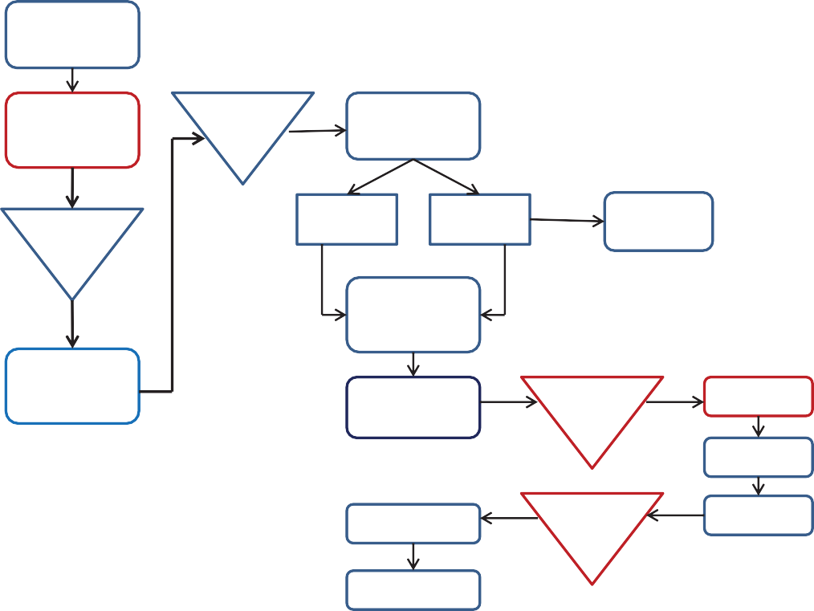

Collect milk

from farms

Transport milk in milk tanker truck

Raw milk storage

Separate raw milk (3000 gal/h)

Receiving/ Transfer Stations

Raw skim milk

Raw cream

Sell bulk cream

Standardize (1%, 2%, FF,

etc.)

Transport milk in milk tanker truck

Pasteurize (6400 gal/h)

Pasteurized milk storage

Package

Case

Load Trailers

Refrigerated

storage

Stack

Lab tests

Ship

**Figure 2.** Fluid Milk Processing

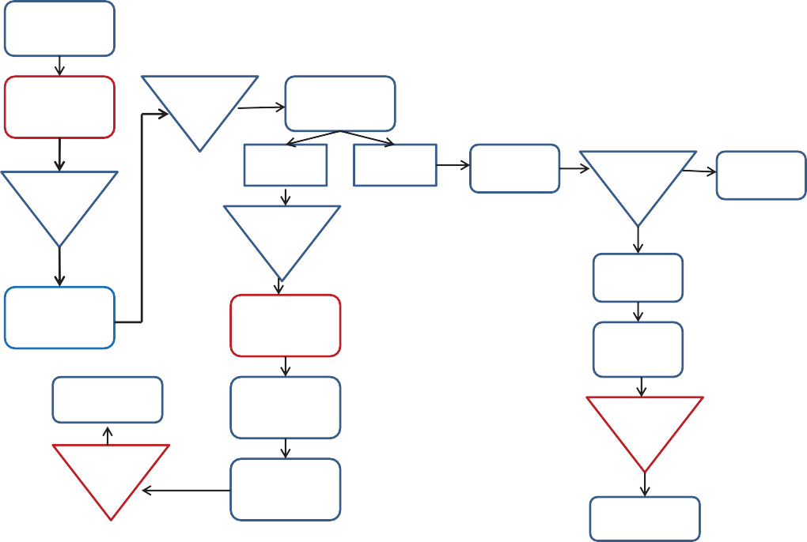

Collect milk

from farms

Transport milk in milk tanker truck

**Raw milk storage**

Separate raw milk (34 800 gal/h)

Raw skim milk

Raw cream

Pasteurize

Receiving/ Transfer Stations

**Pasteurized cream storage**

Sell bulk cream

**Balance tanks**

Butter Churn (872 gal/h)

Transport milk in milk tanker truck

Pasteurize Evaporate

(26 740 gal/h)

Bulk packing

Ship to

Customers

Dry at 440 F (1395 gal/h)

**Freezer**

**storage**

**Storage**

**(16 days)**

Bag Powder

(2790 gal/h)

Lab tests

Ship to Brokers

**Figure 3.** Manufacturing Operations

# Industry Overview

The U.S. dairy industry is a $110 billion/year industry supported by more than 51,000 dairy farm families across the country. Its total economic output is estimated at $140 billion, encompassing $29 billion in household earnings and more than 900,000 jobs.2 Ninety-seven percent of U.S. dairy farms are family-owned.

## Production and Dairy Cow Population

As shown in Figure 4, the total number of U.S. dairy farm operations has decreased since 2001, even though overall milk production and the dairy cow population have both increased.3 This shift is due to the rise in large dairy operations of 500 or more dairy cows, as well as increased production per cow on both larger and smaller operations as a result of U.S. farmers’ more efficient methods of selecting, breeding, and feeding dairy cows. Table 1 shows that the U.S. has the most productive dairy farms in the world. U.S. milk production totalled nearly 193 billion pounds in 2010, a historical record for total milk output per cow that was achieved with the fewest cows in the U.S. (9.1 million) since 2005.4

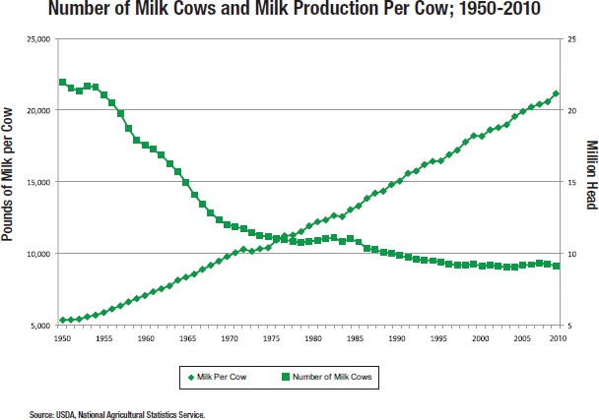

**Figure 4.** The Evolution of US Dairy Farms5

1. “The U.S. Dairy Industry: A Vital Contributor to Economic Development.” Web 22 June 2012.

[<http://www.dair](http://www.dairyfarmingtoday.org/LearnMore/FactsandFigures/Pages/FactsFigures.aspx)y[farmingtoday.org/LearnMore/FactsandFigures/Pages/FactsFigures.aspx>.](http://www.dairyfarmingtoday.org/LearnMore/FactsandFigures/Pages/FactsFigures.aspx)

1. “Overview of the United States Dairy Industry.” National Agricultural Statistics Service (NASS) et al. 22 September 2010. Web 22 July 2012.

[<http://www](http://www.google.com.co/url?sa=t&rct=j&q&esrc=s&source=web&cd=1&ved=0CFsQFjAA&url=http).[google.com.co/url?sa=t&rct=j&q=&esrc=s&source=web&cd=1&ved=0CFsQFjAA&url=http](http://www.google.com.co/url?sa=t&rct=j&q&esrc=s&source=web&cd=1&ved=0CFsQFjAA&url=http)

%3A%2F%2Fusda.mannlib.cornell.edu%2Fusda%2Fcurrent%2FUSDairyIndus%2FUSDairyIndus-09-22- 2010.pdf&ei=zpEIUPKtOIyQ8wSOq5S7BA&usg=AFQjCNHTXztdDF7x74WNILJJVE

S6fUt13w>.

1. “Dairy Facts 2011 Edition.” International Dairy Foods Association. November 2011.

<[www.idfa.org/bookstore/#category_121/>](http://www.idfa.org/bookstore/%23category_121/)

1. Dairy Facts 2011 Edition.

Figure 5 details fluid milk product sales by product category. While domestic sales have stabilized in the past decade, U.S. dairy product exports increased in volume in 2010 by 38.9% over the previous year. Leading U.S. exports by value include non-fat dry milk, cheeses, and whey products. Top export customers by value are Mexico, Southeast Asia and Canada.6

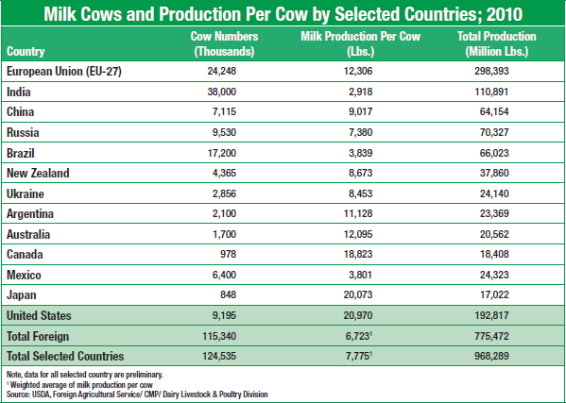

**Table 1.** Dairy Farming in Selected Countries7

1. “Summary of U.S. Exports – May 2012.” United States Dairy Export Council. 12 July 2012. Web 23 July 2012.

[<http://www](http://www.google.com.co/url?sa=t&rct=j&q&esrc=s&source=web&cd=1&ved=0CFMQFjAA&url=htt).[google.com.co/url?sa=t&rct=j&q=&esrc=s&source=web&cd=1&ved=0CFMQFjAA&url=htt](http://www.google.com.co/url?sa=t&rct=j&q&esrc=s&source=web&cd=1&ved=0CFMQFjAA&url=htt) p%3A%2F%2Fusdec.files.cms-plus.com%2FTradeData%2FPDFs%2FSummary%2520of%2520U. S.%2520Exports%2520Year-To-Date%2520.pdf&ei=v3EPUMqjHI6Y8gSbwIH4CQ&usg=AFQjCNG 45q992p5HnSMZz0TRz1eRthaNzw&sig2=vGq79jmnT2Y0qOSEtT8BMQ.>

1. Dairy Facts 2011 Edition.

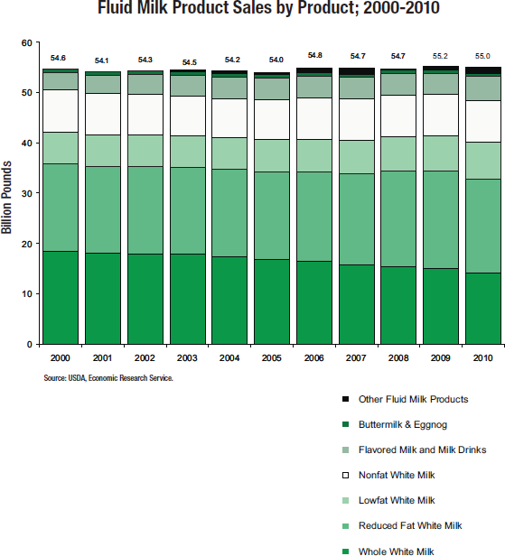

## Milk Pricing

**Figure 5.** Milk Sales in the US8

In the past decade, the U.S. government-mandated federal milk pricing level per hundredweight (cwt.) of fluid milk has fluctuated between $12.18 and $19.21. These fluctuations have contributed to the diminishing number of total dairy operations in the U.S., some of which were forced out of business due to the global financial crisis in 2009, when low milk prices and increased feed costs made it impossible for some operations to continue.9 As shown in Figure 6, prices paid by processing plants to U.S. dairy farmers increased in 2010 by 27% to $16.29/cwt, the third highest price on record. The price premiums are mainly driven by the quality of raw milk and by local demand-supply mismatches.

1. *Ibid*.
2. “Overview of the United States Dairy Industry.”

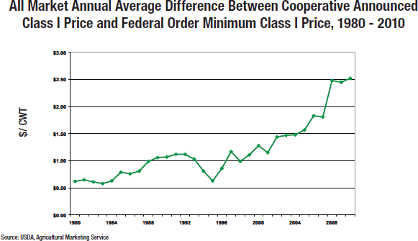

**Figure 6.** Class I Milk Prices

The same trend and volatility are also noticeable for manufactured products around the world. Figure 7 reflects U.S. and international wholesale prices for butter.

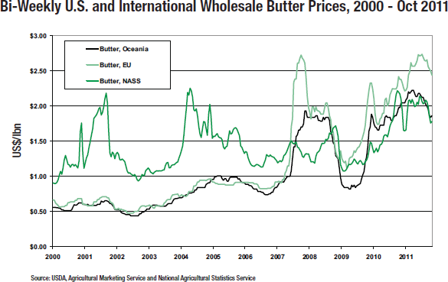

**Figure 7.** Price Volatility for Manufactured Products

## Crisis Preparedness

Milk is the most closely inspected food product by the U.S. and state governments. The U.S. dairy industry therefore places a strong emphasis on crisis preparedness and has instituted a robust preparedness program across the U.S. dairy supply chain since 2001, following the outbreaks of bovine spongiform encephalopathy (BSE) and foot-and-mouth disease in the United Kingdom. The terrorist attacks of September 11 and the subsequent anthrax scare in the U.S. confirmed the dairy industry’s decision to invest in crisis preparedness.

The programme has been consistently and jointly managed by the national dairy organizations that represent dairy farmers (Dairy Management Inc.), dairy co-operatives (National Milk Producers Federation), fluid processors (Milk Processor Education Programme), product manufacturers (International Dairy Foods Association), and ingredient manufacturers and exporters (U.S. Dairy Export Council).

The industry’s crisis preparedness programme covers all aspects of the U.S. dairy supply chain. It includes annual in-person training drills across the U.S., online crisis training programmes, crisis-ready Web sites and social media properties, template situation-specific crisis plans and a wide network of media-trained academic and government partners who can serve as third-party experts in the event of a crisis.

## The Workshop on Risk Management

As he opened a bottle of chocolate milk, Fred Calvert asked his colleagues to organize the identified sources of risk in a matrix that reflected the likelihood and the impact of a potential risk. This would be the first step in classifying these risks, developing mitigation strategies, and assessing crisis preparedness.

“Who wants to go first?” he asked.